**DBMS Assignment - 2**

**Description**

A credit card management system is a comprehensive software solution designed to oversee various aspects related to credit cards, including issuing and managing credit cards, handling customer requests and approvals, defining user roles, and establishing relationships between banks, customers, and credit cards.

**Relevance**

The credit card management system is integral to the financial domain, streamlining and securing key processes. Notably, it facilitates collaborative interactions between banks and customers through features like the Customer Credit Card Request Mapping Table and the Customer Credit Card Request Approval Mapping Table, ensuring efficient credit card issuance and approval processes. Realistic attributes, including credit limits and approval statuses, address risk management and regulatory compliance, establishing a robust foundation for responsible credit card management.

The system's incorporation of the Mapping Table for Types of Credit Cards by Bank and the Bank Credit Card Mapping Table enables dynamic relationships, allowing flexible credit card offerings tailored to the specific needs of financial institutions and customers. In essence, the system optimizes interactions, fostering a secure and efficient financial ecosystem.

**ERD Diagram**

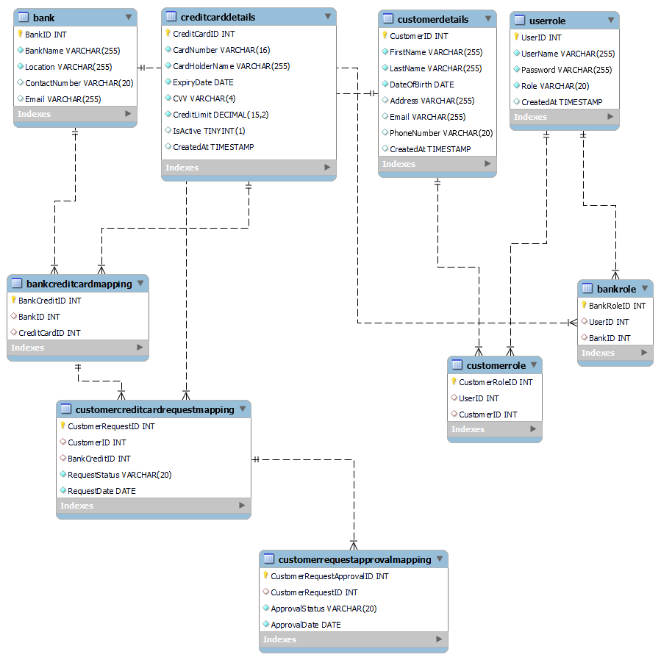

**Table Descriptions**

**1. Bank Table:**

|  |  |  |
| --- | --- | --- |
| **Column** | **Data Type** | **Constraints** |
| BankID | INT | PRIMARY KEY |
| BankName | VARCHAR (255) | NOT NULL |
| Location | VARCHAR (255) | NOT NULL |
| ContactNumber | VARCHAR (20) |  |
| Email | VARCHAR (255 |  |

**2. Credit Card Details Table**

|  |  |  |
| --- | --- | --- |
| **Column** | **Data Type** | **Constraints** |
| CreditCardID | INT | PRIMARY KEY |
| CardNumber | VARCHAR(16) | NOT NULL, UNIQUE |
| CardHolderName | VARCHAR(255) | NOT NULL |
| ExpiryDate | DATE | NOT NULL |
| CVV | VARCHAR(4) | NOT NULL |
| CreditLimit | DECIMAL(15, 2) | NOT NULL |
| IsActive | BOOLEAN | DEFAULT true |
| CreatedAt | TIMESTAMP | DEFAULT CURRENT_TIMESTAMP |

**3. Customer Details Table**

|  |  |  |
| --- | --- | --- |
| **Column** | **Data Type** | **Constraints** |
| CustomerID | INT | PRIMARY KEY |
| FirstName | VARCHAR(255) | NOT NULL |
| LastName | VARCHAR(255) | NOT NULL |
| DateOfBirth | DATE | NOT NULL |
| Address | VARCHAR(255) |  |
| Email | VARCHAR(255) |  |
| PhoneNumber | VARCHAR(20) |  |
| CreatedAt | TIMESTAMP | DEFAULT CURRENT_TIMESTAMP |

**4. User Role Table**

|  |  |  |
| --- | --- | --- |
| **Column** | **Data Type** | **Constraints** |
| UserID | INT | PRIMARY KEY |
| UserName | VARCHAR(255) | NOT NULL |
| Password | VARCHAR(255) | NOT NULL |
| Role | VARCHAR(20) | NOT NULL |
| CreatedAt | TIMESTAMP | DEFAULT CURRENT_TIMESTAMP |

**5. Bank Credit Card Mapping Table**

|  |  |  |
| --- | --- | --- |
| **Column** | **Data Type** | **Constraints** |
| BankCreditID | INT | PRIMARY KEY |
| BankID | INT | FOREIGN KEY (BankID) |
| CreditCardID | INT | FOREIGN KEY (CreditCardID) |

**6. Customer Credit Card Request Mapping Table**

|  |  |  |
| --- | --- | --- |
| **Column** | **Data Type** | **Constraints** |
| CustomerRequestID | INT | PRIMARY KEY |
| CustomerID | INT | FOREIGN KEY (CustomerID) |
| BankCreditID | INT | FOREIGN KEY (BankCreditID) |
| RequestStatus | VARCHAR(20) | NOT NULL |
| RequestDate | DATE | NOT NULL |

**7. Customer Credit Card Request Approval Mapping Table**

|  |  |  |
| --- | --- | --- |
| **Column** | **Data Type** | **Constraints** |
| CustomerRequestApprovalID | INT | PRIMARY KEY |
| CustomerRequestID | INT | FOREIGN KEY (CustomerRequestID) |
| ApprovalStatus | VARCHAR(20) | NOT NULL |
| ApprovalDate | DATE | NOT NULL |

**8. Bank Role Table**

|  |  |  |
| --- | --- | --- |
| **Column** | **Data Type** | **Constraints** |
| BankRoleID | INT | PRIMARY KEY |
| UserID | INT | FOREIGN KEY (UserID) |
| BankID | INT | FOREIGN KEY (BankID) |

**9. Customer Role Table**

|  |  |  |
| --- | --- | --- |
| **Column** | **Data Type** | **Constraints** |
| CustomerRoleID | INT | PRIMARY KEY |
| UserID | INT | FOREIGN KEY (UserID) |
| CustomerID | INT | FOREIGN KEY (CustomerID) |